# Game Design

## Concept

The concept of this game is a card based memory game. Players must match pairs of cards from two different decks. The game begins with a two sets of cards laid out on the screen all face down, one set of radiation cards and another set of protection cards. The player clicks on a card from the first set to turn it over revealing its symbol and then clicks on another card from the second set to do the same. If the type of protection matches with the type of radiation then the cards are removed and the player scores points. Bonus points can be scored by revealing a specific matching pair shown at the top of the screen at certain times.

## Objectives and Scoring

The objective of the game is to clear all of the cards from the playing area before the time limit expires. Players will score 5 points for every pair of cards they correctly match, 20 bonus points can be scored for matching the cards indicated in the user interface. If the player completes the level before the time has run out then they will also score 1 point for every second left on the clock.

If the player matches more than 1 pair in a row they earn a 2x score multiplier where every matched pair is worth double points. If they match 4 in a row they will earn a 3x multiplier and earn a power up.

## Bonus Card

The player can score a bonus 20 points by correctly matching the bonus pair as indicated on the User Interface. The Bonus pair will be a randomly selected pair from the selection of cards and will only be available to the player once for 10 seconds and will appear at a random time during the game.

## Power Up

The player will be able to earn a power up where they will be able to reveal all the cards for a short time (1 second). This power up will be earned by matching 4 pairs in a row and will be selectable from the User Interface.

## Hint

The player will be able to get a hint for a point deduction of 7 points * difficulty per hint. The hint will highlight a pair to the player for 1 second.

## Difficulty

There will be three different levels of difficulty for the game; Easy, Medium and Hard. The differences between them shall be as follows:

Easy – 12 pairs of cards to match, descriptions on cards, normal scoring, 1.5 minute time limit.

Medium – 18 pairs of cards to match, descriptions, double scoring, 1.5 minute time limit.

Hard – 24 pairs of cards to match, no descriptions, triple scoring, 1.5 minute time limit.

## Controls

The main method of controlling the game will be via the mouse. Players will use the mouse to navigate around menus and will also use it to select cards. The keyboard will be used for entering the players name into the high score table, with the arrow keys also available to navigate menus

Mouse – Navigate menus, left click to select card/menu item

Esc – Go back

Arrow Keys – Navigate menus/highlight card

Enter – Select menu item/card

## User Interface

The main game screen will consist of the following items:

* The main play area – the area where the cards are displayed and interacted with
* Score – this will be displayed in the top right hand corner of the screen
* Time – the remaining time will be displayed in the top right below the score
* Bonus indicator – the card worth bonus points will be displayed in the right hand side of the screen in the centre for as long as the bonus is active for.
* Power-Up – A button for the power up only active when one available.
* Hint – A button for the hint.
* Menu – A menu bar comprising of new game, high score, help and exit.

## Sketches

The following screens will be presented to the player when they begin the game:

* Title and Description Screen – the title of the game and a short description of what the player has to do, including a list of all the cards the player will see in the game
* Game play screen – the game
* High score table – a chance for the player to enter their score into the table and compare it to other players

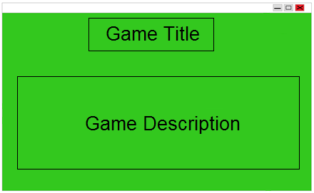Some initial sketches of what the game will look like are included below:

Game title and description screen

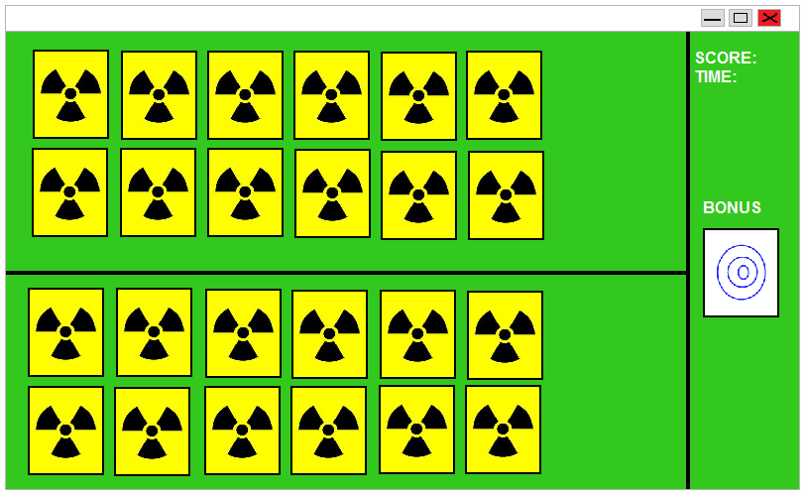

Game play screen, showing play area, score, time and bonus card